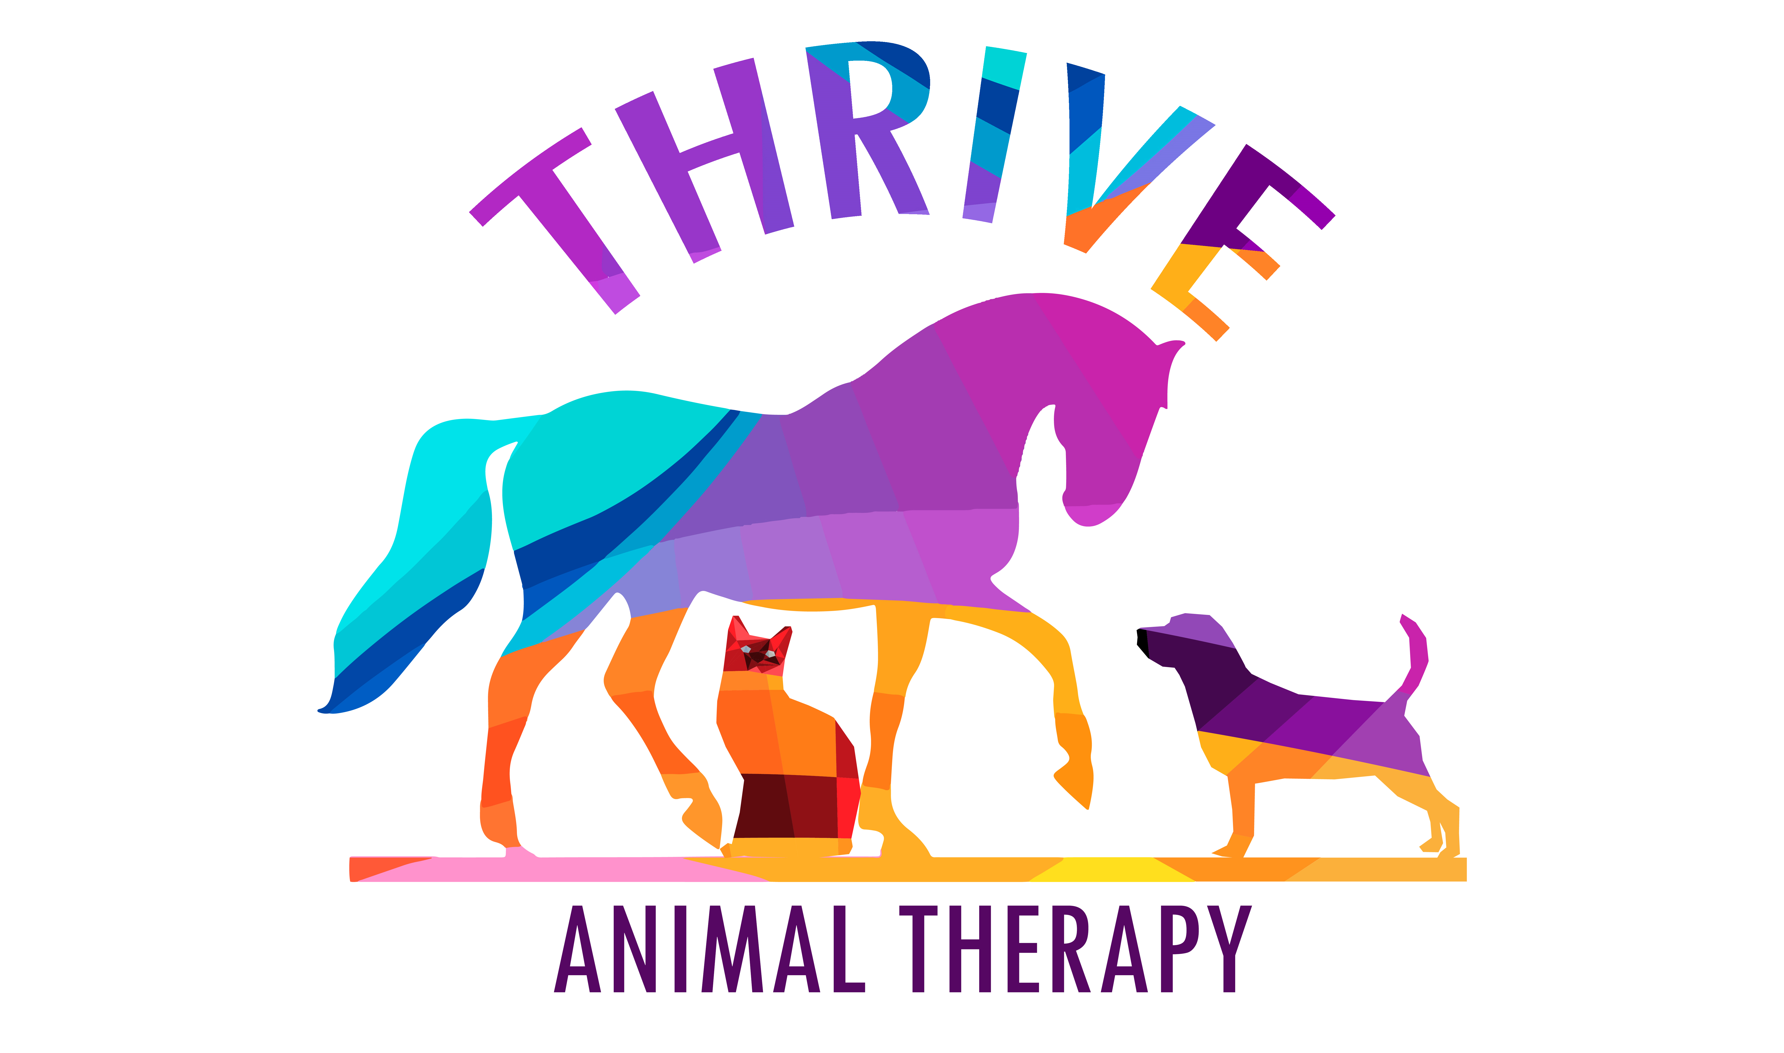
Equine Information Sheet
HORSE INFORMATION
NAME: | AGE: | SEX:
BREED: | COLOUR: | HEIGHT:
WEIGHT: | DATE OF LAST VACCINATION: | DATE LAST WORMED:
STABLED/LIVES OUT: | STABLE SIZE: | BEDDING TYPE:
HAYNET/EATS OFF FLOOR: | EXERCISE LEVEL:

OWNER INFORMATION
NAME:

ADDRESS:

PHONE NUMBER: | EMAIL:
OWNED NAMED HORSE FOR_____ YEARS
HORSE HISTORY (including any accidents, behavioural or ridden problems):

AREAS SENSITIVE OR DIFFICULT TO TOUCH:
ON GOING TREATMENTS OR MEDICATIONS

VET DETAILS
NAME: |  | PERMISSION GIVEN:
PRACTICE ADDRESS: |  |  | VET REPORT REQUIRED?
TELEPHONE: | EMAIL:
VET HISTORY

Disclaimer
Terms and Conditions of Treatment
- Animals will not be treated without permission of their veterinary surgeon in accordance with the Veterinary Surgeons Act 1966 and Exemptions Order 1962.
- Sophie Pickard Animal Therapy will not diagnose any injury or illness for your animal.
- Whilst every care will be taken by Sophie Pickard Animal Therapy when treating your animal it is done entirely at the owner’s risk and Sophie Pickard will not be held responsible or accept any liability for any accident or injuries that occur to animal, owner, handler or property during any treatment session.
- Sophie Pickard Animal Therapy reserves the right to refuse to treat an animal if it is thought the animal seems unwell, has a new undiagnosed lameness, any infection or contagious disease.
- Sophie Pickard Animal Therapy cannot be held responsible for the loss or damage to any vehicles or personal property whilst carrying out any treatment session.
- Owners should be present if possible during their animals’ treatment and should provide suitable restraining equipment for their animal.
- Payment is due on the day of all treatments.

I __________________________ hereby accept these terms and conditions of treatment and hereby give my consent for Sophie Pickard Animal Therapy to treat my animal _____________________.

The details and history provided are correct to the best of my knowledge and can confirm that I/Sophie Pickard has obtained veterinary permission from my vet ________________________________ on ____/____/________for my animal ___________________ to be treated by Sophie Pickard Animal Therapy.

Signed: ____________________ Printed Name: ____________________ Date: ____/____/________

